Day 18 - 18th July- 113195064 - Bondili Bhavya Charitha

TASK:1 - At each index, chaining using a linked list
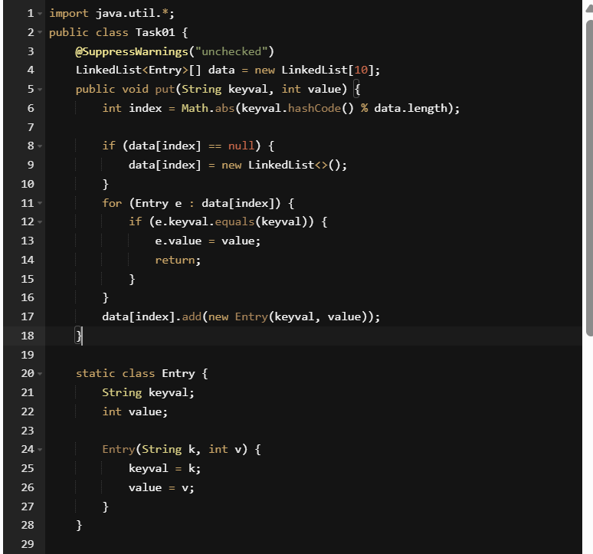

TASK:2- Input from the user a 5 digit no and display digit by digit in the output
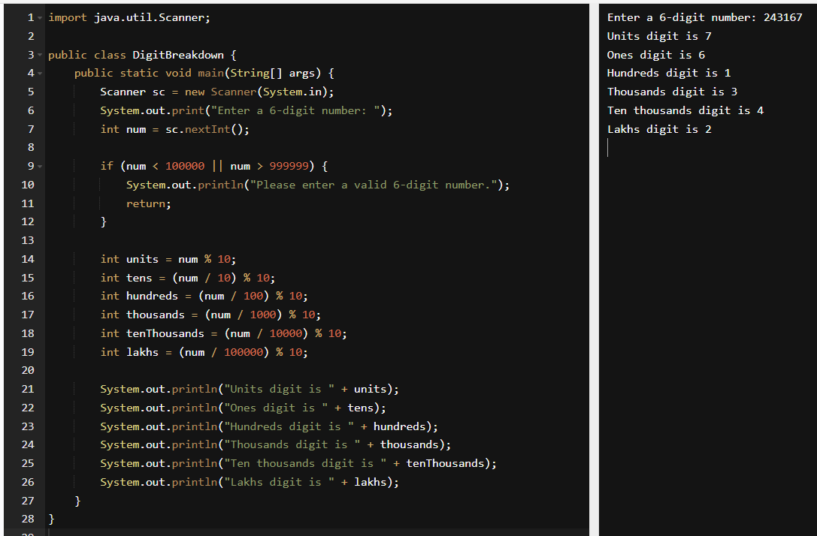
TASK:3 – Wap to take number from the user and display the no of digit it has
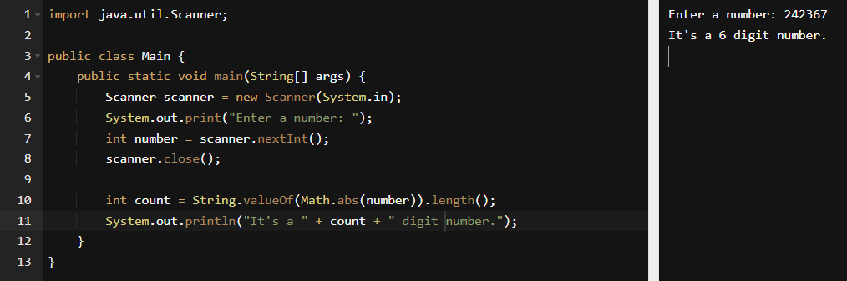

TASK:4 - What are the applications of heap sort?
Heap sort is a powerful and efficient sorting algorithm with a consistent time complexity of O(n log n), making it suitable for a large variety of real-world applications. Here are some of its most notable uses:
- Heap sort forms the basis of priority queue implementations which are used in task scheduling, event handling, and interrupt processing. Ex: Operating systems use priority queues to manage CPU tasks.
- Heaps are essential in algorithms like: Prim’s minimum spanning tree. These rely on efficient retrieval of minimum or maximum values.
- Heap sort’s predictable performance is ideal for real-time applications where timing guarantees are critical.
- Efficient for finding the k-th largest or smallest element in a dataset also useful in statistical analysis and data stream processing.
- Used in Huffman coding, a lossless compression algorithm. Heaps help build the Huffman tree by repeatedly extracting the smallest frequencies.
- Garbage collection and memory allocation routines use heaps to manage blocks based on priority or size.
- Preferred in embedded environments due to its in-place sorting and consistent time complexity.
- Heaps help rank web pages or search results based on relevance scores.
- Used to distribute tasks across servers by processing elements with the lowest load first.
- Heaps allow efficient access to the highest-priority job, making them ideal for deadline-driven scheduling.

TASK:5 –
It achieves the same result but emphasizes a recursive style using the same level-order logic with explicit queue management.
- Standard BFS uses an explicit queue to process nodes level by level.
- A recursive BFS is rare and unconventional, but when implemented, it still relies on explicit queue management — just wrapped inside recursive calls.
- It does not eliminate the need for a queue entirely, because level-order traversal inherently requires queue-like behavior.
- It also does not simplify things by using recursion alone — in fact, it can make the logic more complex and harder to debug.
- And it does not process nodes in post-order — that’s a depth-first concept.
TASK:6 –
Heap sort is a powerful and efficient sorting algorithm that uses a binary heap data structure to sort elements.
- Build a Max Heap: Convert the input array into a max heap, where each parent node is greater than its children. This ensures the largest element is at the root of the heap.
- Swap Root with Last Element: Swap the root (largest element) with the last element in the heap. This places the largest element at its correct position in the sorted array.
- Reduce Heap Size: Exclude the last element (now sorted) from the heap. Decrease the effective size of the heap by 1.
- Heapify the Root: Restore the max heap property by calling heapify() on the root. This ensures the next largest element bubbles up to the root.
- Repeat Until Sorted: Continue steps 2–4 until the heap size is reduced to 1. The array is now sorted in ascending order.
TASK:7 –
The system calls stack tracks local variables and return addresses for each recursive invocation.
- Every time a recursive function is called, a new frame is pushed onto the call stack.
- This frame contains:
  - The function’s local variables
  - The return address (where to resume after the call finishes)
- As recursion deepens, the stack grows — and when base cases are hit, the stack unwinds in reverse order, preserving the state of each call.
TASK:8& 9 – Recap of Quiz Done….
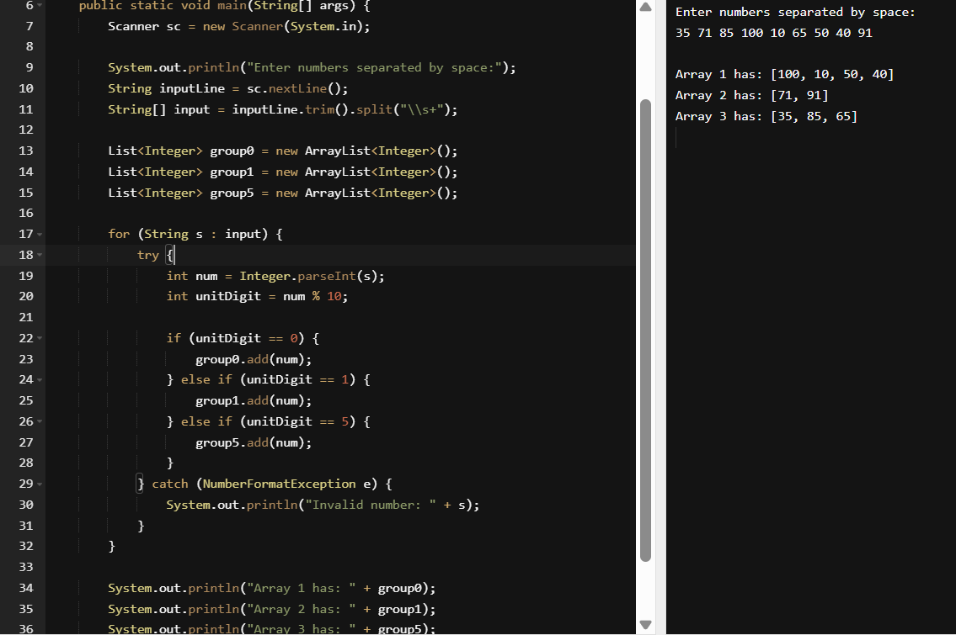
import java.util.ArrayList;
import java.util.List;
import java.util.Scanner;

public class ArrayListExample {
public static void main(String[] args) {
Scanner sc = new Scanner(System.in);

System.out.println("Enter numbers separated by space:");
String inputLine = sc.nextLine();
String[] input = inputLine.trim().split("\\s+");

List<Integer> group0 = new ArrayList<Integer>();
List<Integer> group1 = new ArrayList<Integer>();
List<Integer> group5 = new ArrayList<Integer>();

for (String s : input) {
try {
int num = Integer.parseInt(s);
int unitDigit = num % 10;

if (unitDigit == 0) {
group0.add(num);
} else if (unitDigit == 1) {
group1.add(num);
} else if (unitDigit == 5) {
group5.add(num);
}
} catch (NumberFormatException e) {
System.out.println("Invalid number: " + s);
}
}

System.out.println("Array 1 has: " + group0);
System.out.println("Array 2 has: " + group1);
System.out.println("Array 3 has: " + group5);
}
}

TASK:10 – Print corner nodes of each level
import java.util.*;
public class CornerNodePrinter {
static class TreeNode {
int val;
TreeNode left, right;
TreeNode(int val) {
this.val = val;
}
}
public static void printCornerNodes(TreeNode root) {
if (root == null) return;

Queue<TreeNode> queue = new LinkedList<>();
queue.add(root);

while (!queue.isEmpty()) {
int levelSize = queue.size();
for (int i = 0; i < levelSize; i++) {
TreeNode current = queue.poll();
if (i == 0 || i == levelSize - 1) {
System.out.print(current.val + " ");
}
if (current.left != null) queue.add(current.left);
if (current.right != null) queue.add(current.right);
}
System.out.println();
}
}
public static void main(String[] args) {
TreeNode root = new TreeNode(1);
root.left = new TreeNode(2);
root.right = new TreeNode(3);
root.left.left = new TreeNode(4);
root.left.right = new TreeNode(7);
root.right.right = new TreeNode(15);
root.left.right.left = new TreeNode(8);
root.left.right.right = new TreeNode(11);
root.right.right.left = new TreeNode(12);
root.right.right.right = new TreeNode(14);
System.out.println("Corner nodes of each level:");
printCornerNodes(root);
}
}

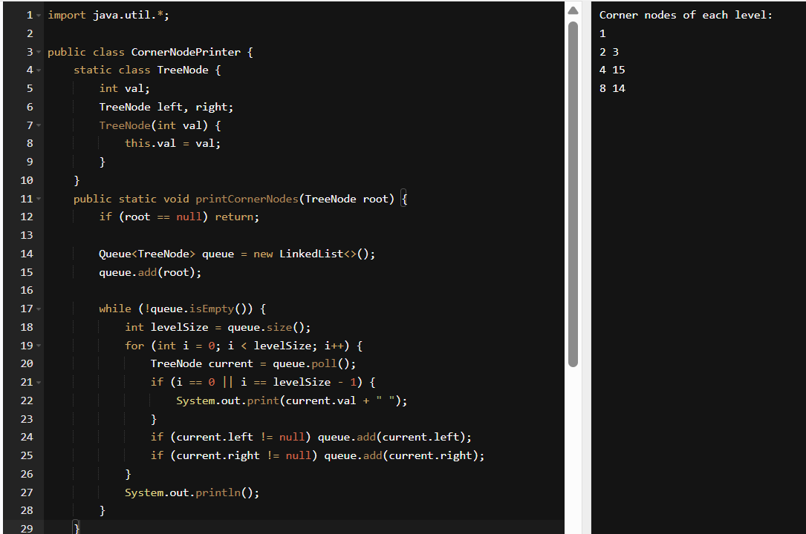
TASK:11,12,13 & 14 – Quiz Questions done.

TASK:15 – Algorithm for Radix Sort
- Check if all the input elements have same number of digits. If not, check numbers that have maximum number of digits in the list and add leading zeroes to the ones that do not.
- Take the least significant digit/units digit of each element.
- Sort these digits using counting sort logic and try to change the order of elements depending on the output achieved.
- Repeat step 2 for next least significant digits until all digits in given elements are sorted.
- The final list of elements achieved after kth loop is the sorted output.

TASK:16 - Pseudo code for radix sort
RadixSort(arr[], n):
max = arr[0]
for (i=1 to n-1):
if (arr[i]>max):
max=arr[i]
For (pos=1 to max/pos>0):
countSort(arr, n, pos)
pos=pos*10

TASK:17 – Code for Radix Sort
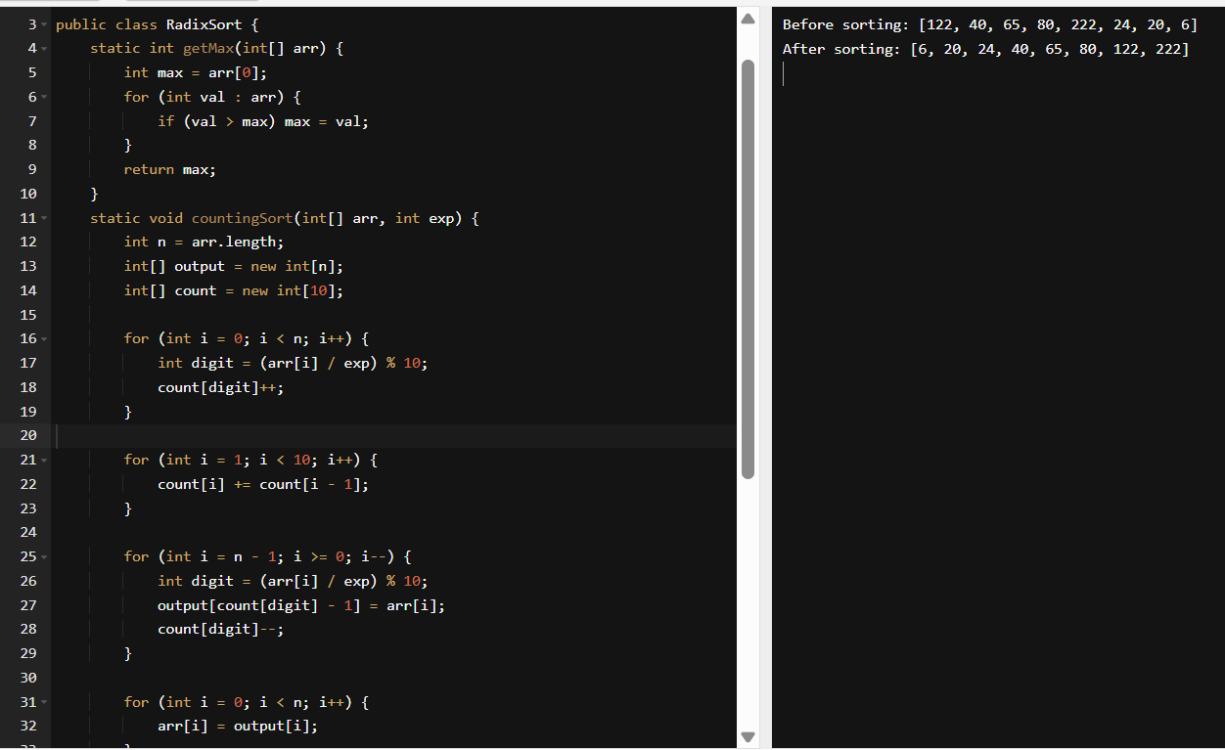
import java.util.Arrays;

public class RadixSort {
static int getMax(int[] arr) {
int max = arr[0];
for (int val : arr) {
if (val > max) max = val;
}
return max;
}
static void countingSort(int[] arr, int exp) {
int n = arr.length;
int[] output = new int[n];
int[] count = new int[10];

for (int i = 0; i < n; i++) {
int digit = (arr[i] / exp) % 10;
count[digit]++;
}

for (int i = 1; i < 10; i++) {
count[i] += count[i - 1];
}

for (int i = n - 1; i >= 0; i--) {
int digit = (arr[i] / exp) % 10;
output[count[digit] - 1] = arr[i];
count[digit]--;
}

for (int i = 0; i < n; i++) {
arr[i] = output[i];
}
}

static void radixSort(int[] arr) {
int max = getMax(arr);
for (int exp = 1; max / exp > 0; exp *= 10) {
countingSort(arr, exp);
}
}

public static void main(String[] args) {
int[] arr = {122, 40, 65, 80, 222, 24, 20, 6};
System.out.println("Before sorting: " + Arrays.toString(arr));
radixSort(arr);
System.out.println("After sorting: " + Arrays.toString(arr));
}
}
TASK:18 – Quiz Answers Done.

Home Tasks:
- Display all corner elements of a tree.
import java.util.*;
class Node {
int data;
Node left, right;

Node(int value) {
data = value;
left = right = null;
}
}
public class TreeCornerElements {
public static void printCornerElements(Node root) {
if (root == null) return;
Queue<Node> queue = new LinkedList<>();
queue.add(root);
while (!queue.isEmpty()) {
int levelSize = queue.size();
Node first = null, last = null;
for (int i = 0; i < levelSize; i++) {
Node current = queue.poll();

if (i == 0) first = current;
if (i == levelSize - 1) last = current;

if (current.left != null) queue.add(current.left);
if (current.right != null) queue.add(current.right);
}
if (first != null) System.out.print(first.data);
if (last != null && last != first) System.out.print(" " + last.data);
System.out.println();
}
}
public static void main(String[] args) {
Node root = new Node(1);
root.left = new Node(2);
root.right = new Node(3);
root.left.left = new Node(4);
root.left.right = new Node(5);
root.right.left = new Node(6);
root.right.right = new Node(7);
System.out.println("Corner elements of the tree:");
printCornerElements(root);
}
}

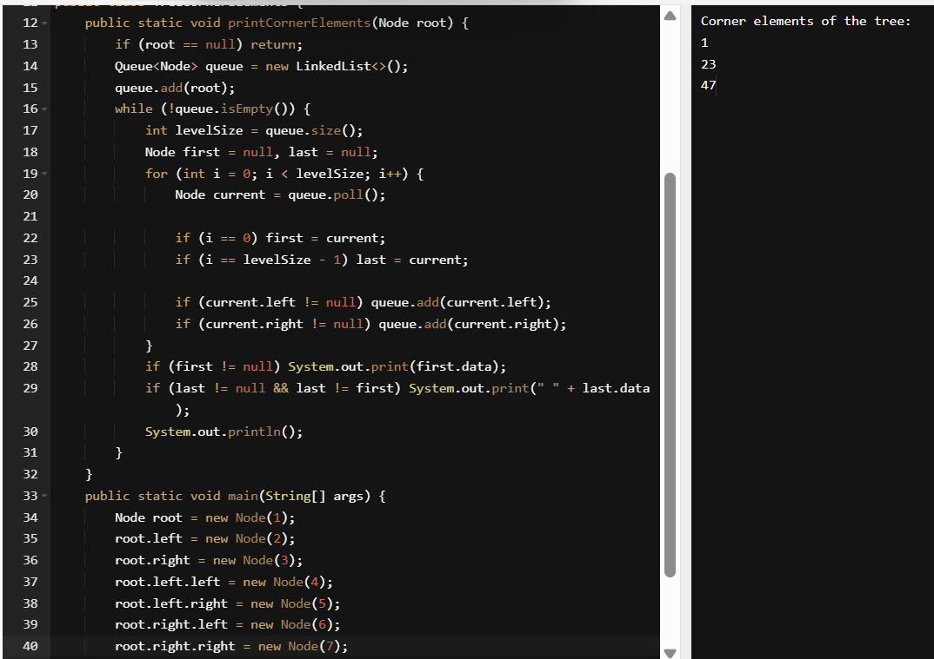

- Reverse Alternate levels
import java.util.*;
class Node {
int data;
Node left, right;

Node(int value) {
data = value;
left = right = null;
}
}
public class ReverseAlternateLevels {
public static void reverseAlternateLevels(Node root) {
reverseUtil(root.left, root.right, 1);
}
private static void reverseUtil(Node left, Node right, int level) {
if (left == null || right == null) return;

if (level % 2 == 1) {
int temp = left.data;
left.data = right.data;
right.data = temp;
}
reverseUtil(left.left, right.right, level + 1);
reverseUtil(left.right, right.left, level + 1);
}
public static void printTree(Node root) {
if (root == null) return;
Queue<Node> queue = new LinkedList<>();
queue.add(root);

while (!queue.isEmpty()) {
int levelSize = queue.size();

for (int i = 0; i < levelSize; i++) {
Node current = queue.poll();
System.out.print(current.data + " ");

if (current.left != null) queue.add(current.left);
if (current.right != null) queue.add(current.right);
}

System.out.println();
}
}
public static void main(String[] args) {
Node root = new Node(1);
root.left = new Node(2);
root.right = new Node(3);
root.left.left = new Node(4);
root.left.right = new Node(5);
root.right.left = new Node(6);
root.right.right = new Node(7);
System.out.println("Tree before reversal:");
printTree(root);
reverseAlternateLevels(root);
System.out.println("\nTree after reversing alternate levels:");
printTree(root);
}
}

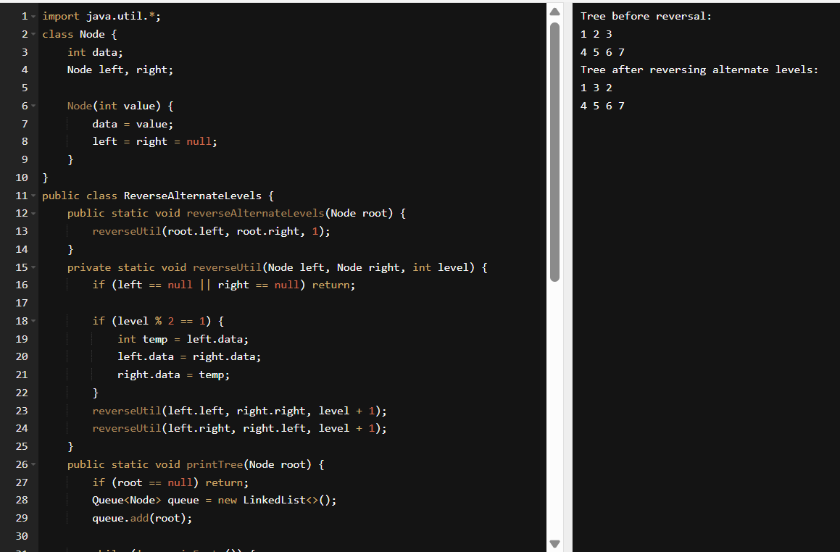

- Leet problem solved – Done
- Add On: Wap to display the groups of digits depending upon the unit digits
Hint: If input is 45,81, 85,100,20. 95,60,10,21
Output: Array 1 has: 100,20,60,10. Array 2 has: 81, 21. Array 3 has: 45, 85 ,95.
